
Science as a Human Endeavour (H) and Science Inquiry (I)
Teaching and learning that integrates Science as a Human Endeavour and Science Inquiry could encourage students to reflect on how societal needs,
values and ethics influence scientific inquiry.

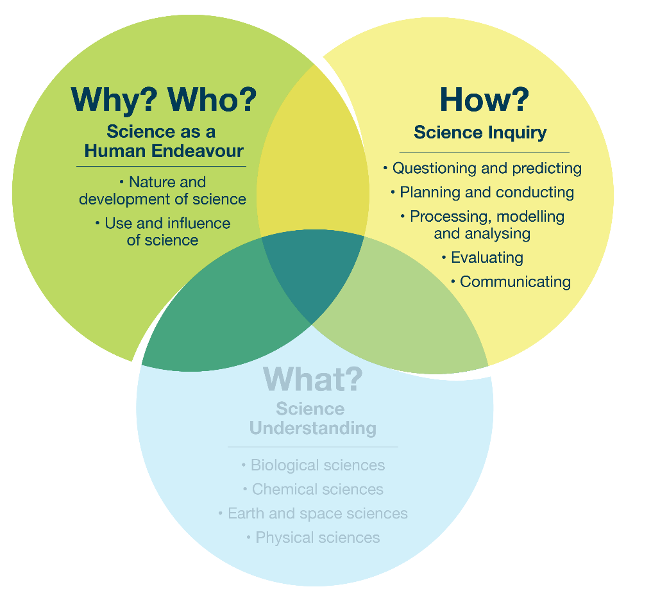
Focus 2.2 – Interconnecting Science as a Human Endeavour and Science Inquiry

Example topic – multiple strands
Before a practical dissection lesson, students could be prompted to discuss the history of and ethical considerations around experimenting on animals.
Possible focus question | Curriculum alignment
Is it justifiable to involve animals in scientific investigations for the purpose of learning? | H link: Considering societal values and decisions about using animals in science  I link: Planning and conducting investigations with attention to ethical responsibilities involving animals  H–I overall link: Students explore how societal ethics inform the responsible use of animals in planning and conducting investigations
Further examples on the next page.

Possible focus question | Curriculum alignment
How have historical uses of animal dissections and experiments shaped modern ethical standards in science? | H link: Reflecting on the historical and societal influences on ethical treatment of animals  I link: Applying past lessons to plan investigations that meet current ethical standards  H–I overall link: Students examine historical and societal influences on ethical standards and use inquiry to align investigations with modern expectations

Possible focus question | Curriculum alignment
How can scientists apply the principles of replacement, reduction and refinement (the 3Rs) to minimise animal use in scientific investigations? | H link: Considering how the application of the 3Rs reflects science’s response to ethical concerns and technological advancements  I link: Applying inquiry skills to design investigations that reduce animal use through alternative methods  H–I link: Students evaluate how ethical principles such as the 3Rs guide scientific inquiry to design investigations that reduce animal use

